

**A CRM APPLICATON TO MANAGE SERVICES OFFERD BY INSTITUTION**

**BY**

T.Ramganesh

([218x1a42a1@khitguntur.ac.in](mailto:218x1a42a1@khitguntur.ac.in))

K.Neeraj

([218x1a4270@khitguntur.ac.in](mailto:218x1a4270@khitguntur.ac.in))

V.Aruna

([218x1a42a8@khitguntur.ac.in](mailto:218x1a42a8@khitguntur.ac.in))

S.SaiKalyan

([218x1a4283@khitguntur.ac.in](mailto:218x1a4283@khitguntur.ac.in))

**PROJECT OVERVIEW**

The CRM (Customer Relationship Management) Application for managing services offered by an institution aims to optimize the relationship between the institution and its clients, such as students or customers. The application centralizes client data, service history, and communication logs, enabling efficient tracking and management of all interactions. It allows the institution to manage a range of services, including course registrations, event scheduling, and appointments, while also providing a platform to handle inquiries and feedback. With features like automated follow-ups, personalized communication, and reminders, the CRM enhances engagement and service delivery. Additionally, it supports data analysis and reporting, enabling the institution to identify trends and areas for improvement. The system can also facilitate service customization, offering tailored solutions to meet specific client needs. By automating administrative tasks, the application reduces the workload for staff and improves overall operational efficiency.

**INTRODUCTION**

A CRM (Customer Relationship Management) application for managing services offered by an institution is a powerful tool designed to streamline communication and service delivery. This system helps institutions efficiently manage client or student interactions, track service requests, and maintain a detailed record of all engagements. By centralizing data and automating administrative tasks, the application improves operational efficiency, enhances customer satisfaction, and fosters stronger relationships.

**OBJECTIVES:**

The objectives of the CRM Application to Manage the Services offered by an Institution are as follows:

1. **Centralized Data Management**: To centralize client or student information, including service history, inquiries, and feedback, providing easy access to relevant data.
2. **Enhanced Communication**: To streamline communication between the institution and clients, offering personalized follow-ups, reminders, and automated messaging for timely responses.
3. **Efficient Service Tracking**: To monitor and manage all services offered, such as course registrations, appointments, and events, ensuring smooth execution and customer satisfaction.
4. **Improved Client Engagement**: To foster stronger relationships with clients or students through customized service offerings and real-time interaction tracking.
5. **Process Automation**: To automate administrative tasks, including scheduling, reminders, and notifications, reducing the workload on staff and improving operational efficiency.
6. **Data Analytics & Reporting**: To provide analytical tools that help the institution understand trends, measure performance, and identify areas for improvement.
7. **Increased Client Satisfaction**: To enhance the overall experience of clients by ensuring timely, personalized, and efficient service delivery.
8. **Scalable & Flexible Solution**: To create a scalable CRM solution that can be adapted to various services and expanded as the institution grows.

**METHODOLOGY:**

The methodology for developing the CRM Application to Manage the Services offered by an Institution follows a systematic approach to ensure the application meets user needs and delivers optimal results. The methodology includes the following steps:

1. **Requirement Analysis**:
   * Gather detailed requirements by conducting meetings with stakeholders such as institution management, staff, and clients.
   * Define the specific services offered by the institution, client needs, and the necessary CRM features (e.g., scheduling, communication, service tracking).
2. **System Design**:

Design the system to include different user roles (e.g., admin, staff, student, or customer) with defined permissions for accessing specific features such as service requests, reports, and communication. This ensures that users only access information relevant to their role and enhances security.

1. **Development Phase**:
   * Implement the CRM application in an iterative manner, starting with the core features like data management, communication tools, and service tracking.
   * Regularly test modules for bugs and integration issues during.
2. **Deployment**:
   * Deploy the application on a suitable server or cloud environment, ensuring scalability and security.
   * Implement data migration processes if necessary, ensuring a smooth transition from legacy systems to the new CRM.
3. **Evaluation & Feedback**:
   * Continuously evaluate system performance, client satisfaction, and overall efficiency improvements.Collect feedback regularly to guide future updates

**Salesforce Key Features and Concepts Utilized:**

Here’s the corrected version with "Page Layouts" replaced by "Flows":

1. **Salesforce Objects**: Custom and standard objects can be used to store and manage data like services, requests, and user interactions within the institution.
2. **Record Types**: Different record types for service requests, user feedback, or department-specific cases to tailor the data entry and workflows.
3. **Flows**: Automate complex business processes, such as service request submissions or approvals, with Salesforce Flow to guide users through predefined steps.
4. **Automation with Process Builder**: Automate service request assignments, notifications, and approvals based on defined rules or conditions within the org.
5. **Validation Rules**: Ensure data integrity and accuracy by enforcing business logic, like mandatory fields for service requests or client information.
6. **Lightning App Builder**: Create customized applications for service management that provide a seamless user experience within the Salesforce Org.
7. **User Profiles and Permission Sets**: Control access to data and features based on user roles, ensuring that staff and admins have the appropriate permissions.
8. **Salesforce Reports and Dashboards**: Build custom reports and dashboards to analyze and visualize data on service delivery, performance, and user engagement.

**Detailed Steps to Solution Design**

1. **Salesforce developer account creation and activation:**

* To create developer org:
* Go to https://developer.salesforce.com/signup
* On the sign up form, enter the following details:

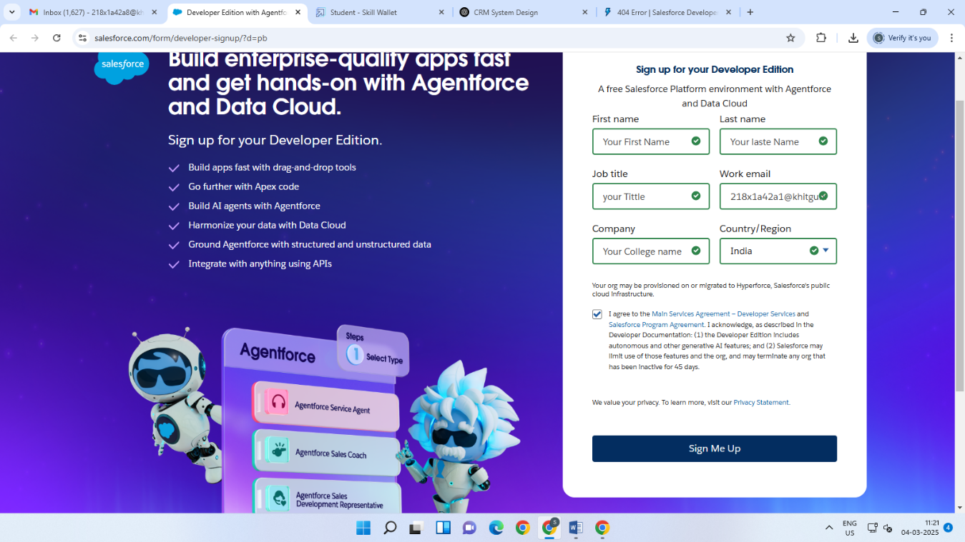

* For account activtion,go to the inbox of the email that you used while

signing up. Click on the verify account to activate your account. The email

may take 5-10mins.

* Click on Verify Account

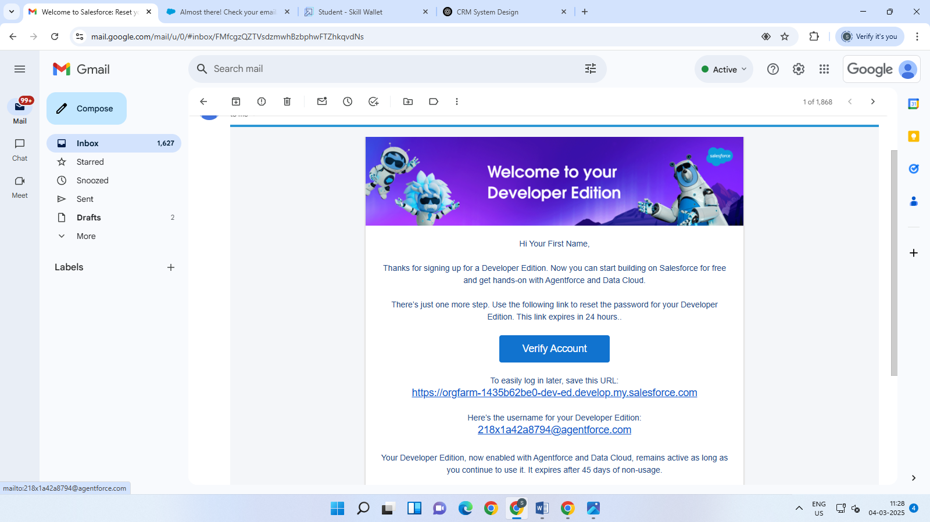

* Give a password and answer a security question and click on change password

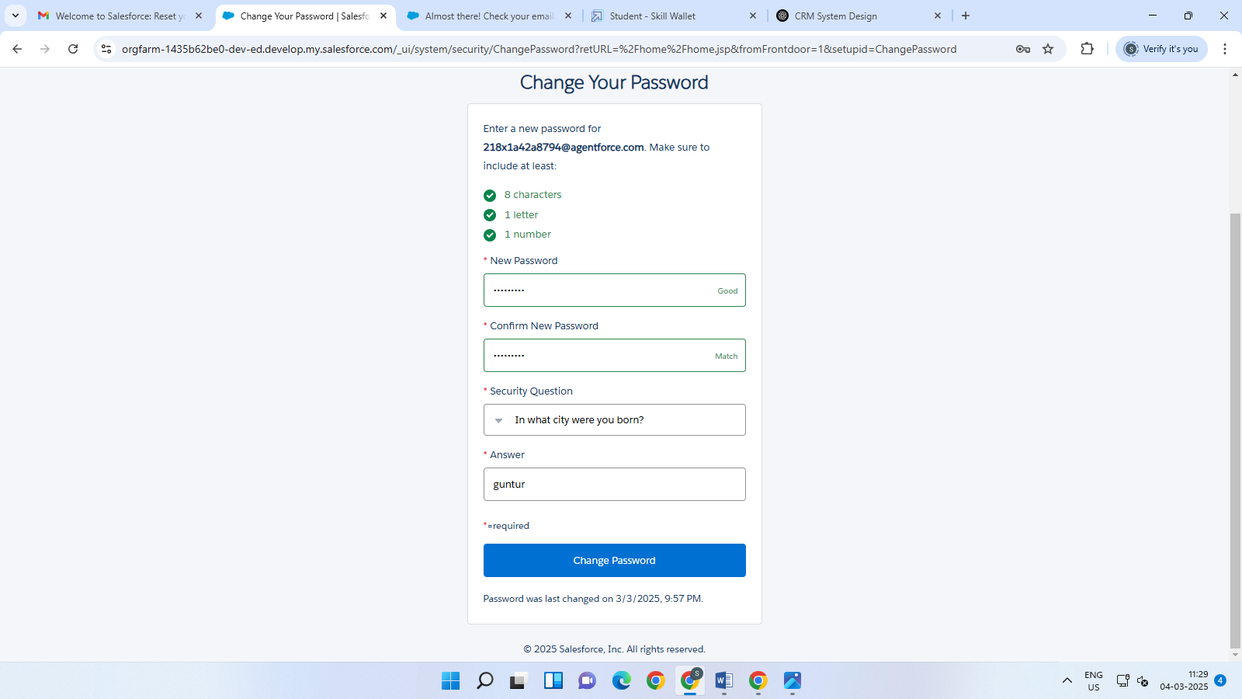

* Then you will redirect to your salesforce setup page.

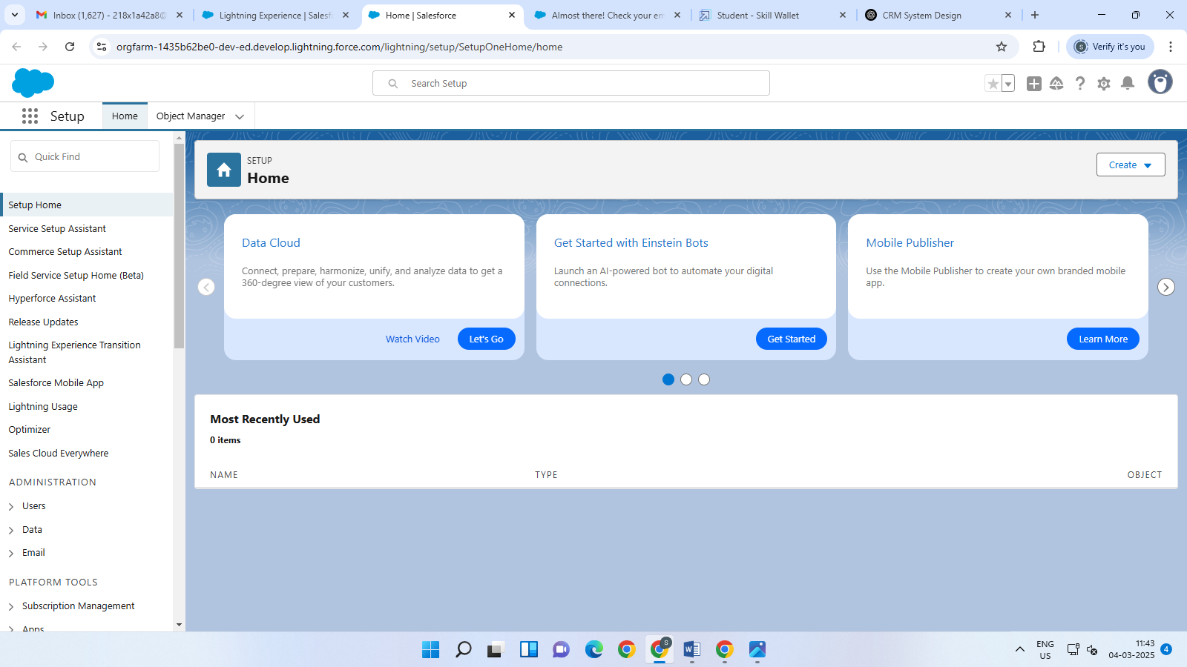

### Create Objects from Spreadsheet

### Create Course object

• Go to the Object Manager in Salesforce.

• **Click on "Create Object from Spreadsheet"** to start the process.

• **Click on the link to download the provided spreadsheet** titled *Course*.

• **Download the file** to your computer.

• **Upload the spreadsheet** back into Salesforce by following the prompts.

• **Map the fields** in the spreadsheet to the relevant fields in Salesforce.

• **Finalize the upload** to create the object in Salesforce.

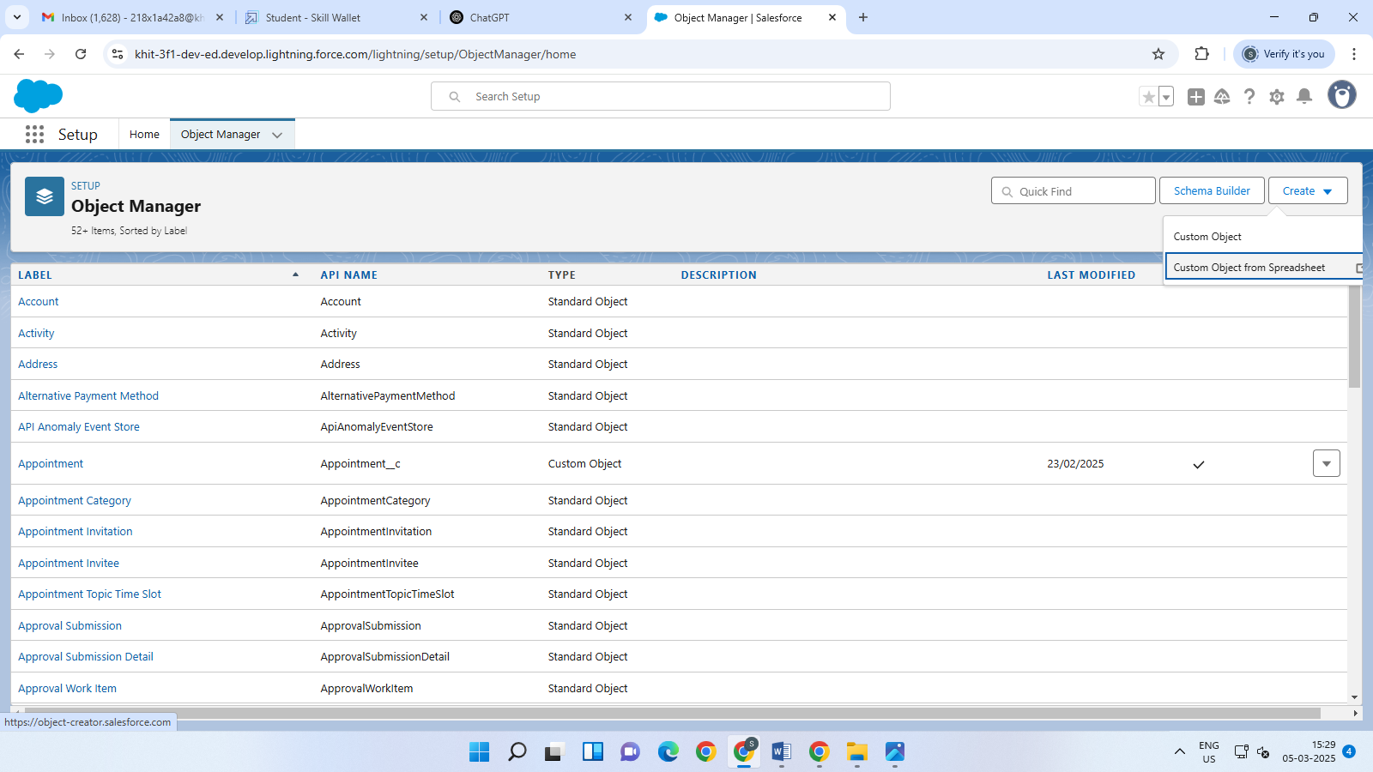

* Label: Appointment
* Plural Label: Appointments
* Enter Record Name Label and Format
* Record Name:  Appointment No
* Data Type: Auto No
* In Optional features: check the boxes for Allow Reports | Allow Activities
* Track Field History.
* Search Status: check the box for Allow Search.
* Save

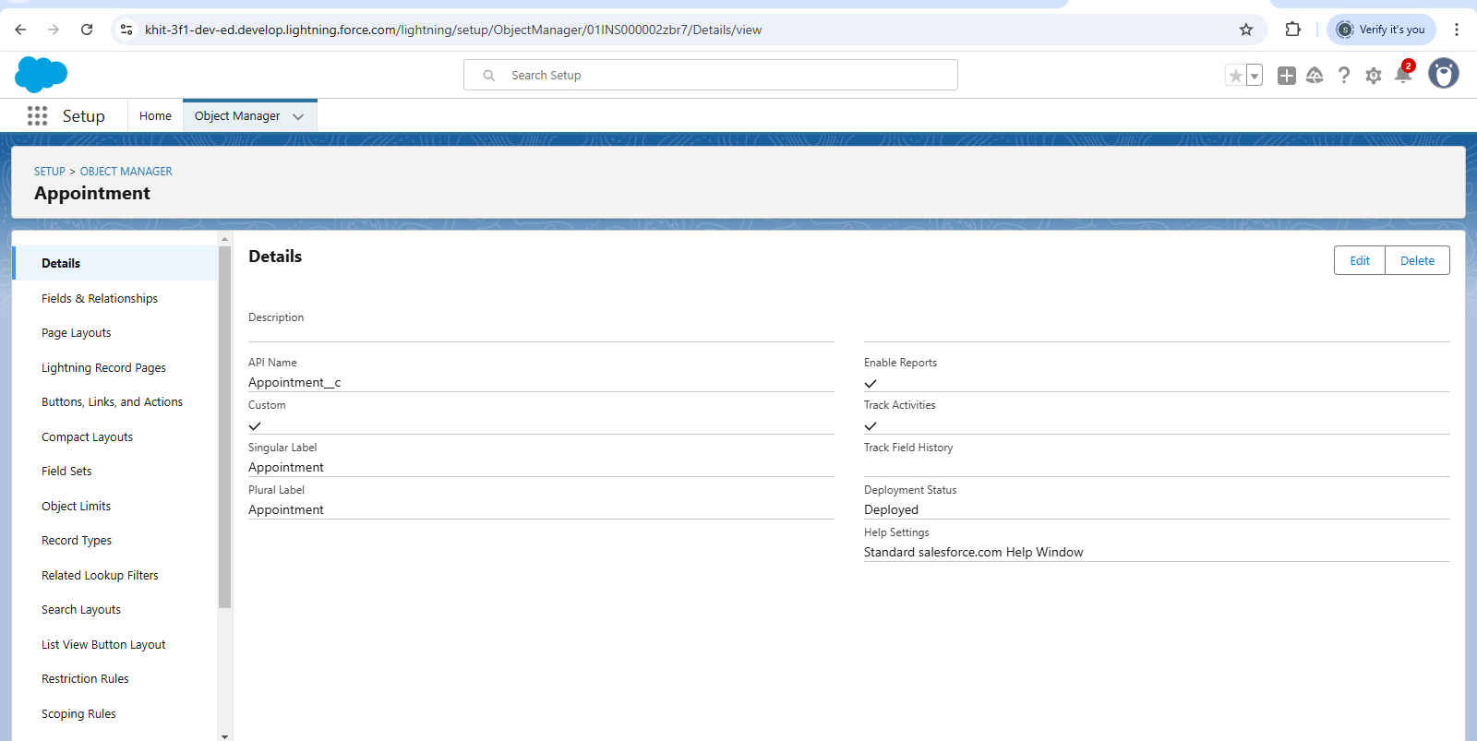

Now repeat the same steps to create Consultant,Course,Registration, and Student Objects

### Create Relationship among the objects:

1. Create lookup between appointment and student, appointment and consultant.
2. Create an object to store the information student and course details with the name Registration.

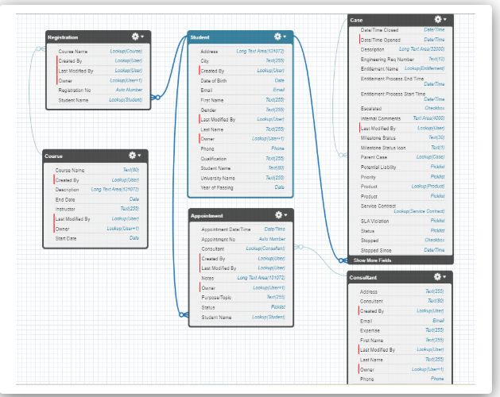

### Configure the Case Object:

Go to **Object Manager**, edit the **Case** object.

Select the **"Type"** field and add the following values:

* Immigration
* Visa Application

Now, select the **"Status"** field and add the following values:

* Open
* In-progress

### Create a Lightning App:

Go to **Setup**, search for **App Manager** in Quick Find.

Click on **New Lightning App**.

Enter the app name as **“EduConsultPro”**, then click **Next**, **Next**, **Next**.

From the **Available Items**, add **Home**, **Students**, **Courses**, **Consultants**, **Appointments**, **Registrations**, and **Cases** to the **Selected Items**.

From the **Available Profiles**, add **System Administrator** profile to the **Selected Profiles**, then click **Save & Finish**.

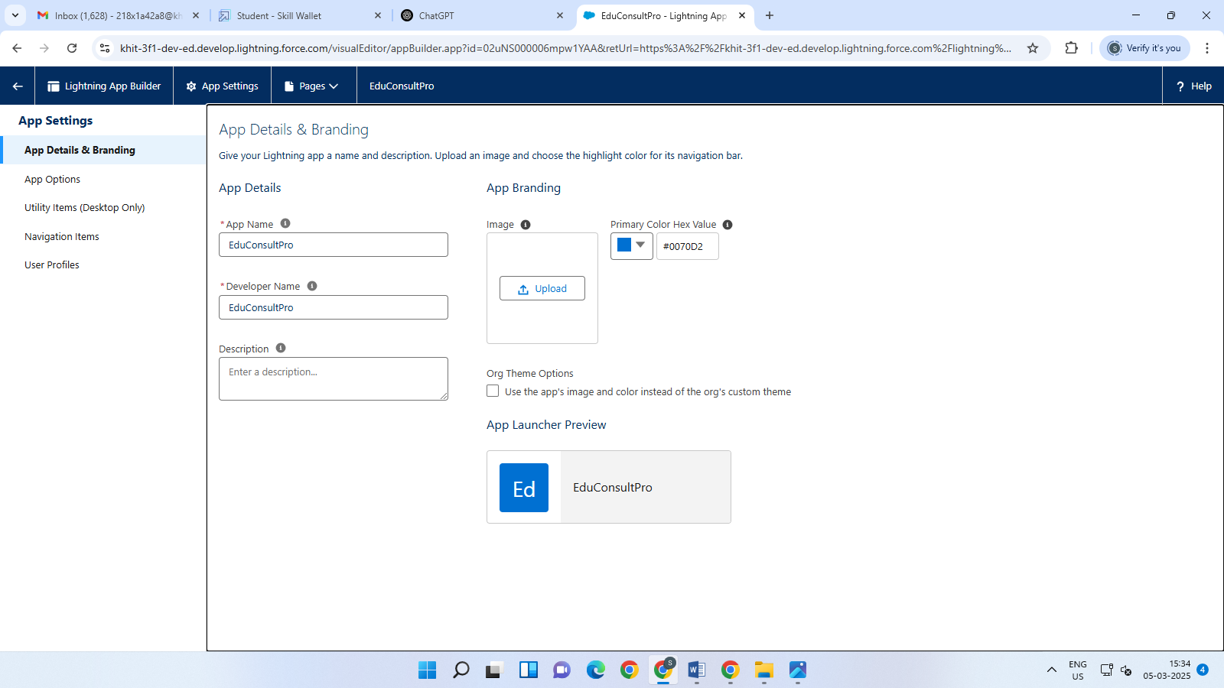

### Create a ScreenFlow for Student Admission Application process.

### Add Screen Element:

From **Setup**, enter **Flow Builder** in Quick Find, then select **New Flow** → **Screen Flow**.

Add a **Screen** element.

In the **Screen Properties** pane, for **Label**, enter **“Student Info”**.

Click on **Fields**, then click on the **Record Variable Input** and create a new Resource (**StudentRecordRes**) to display all the fields from the **Student** object. Drag all the required fields to the screen to collect the student information.

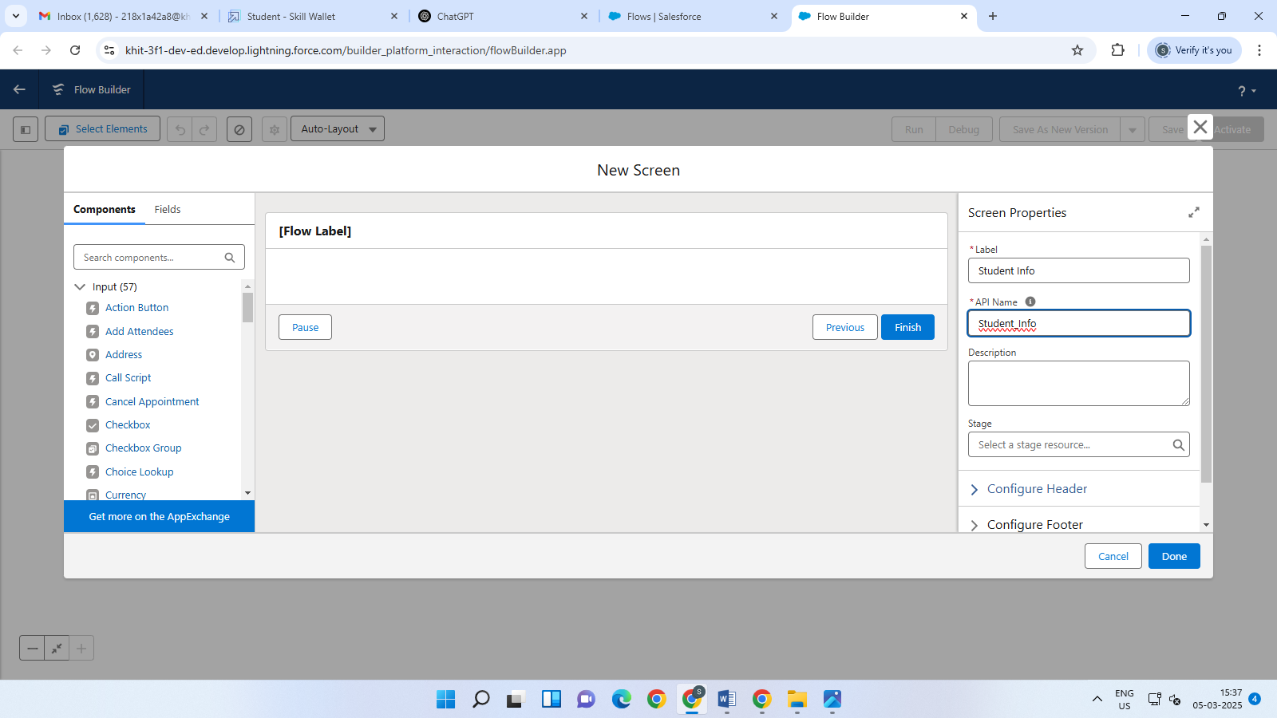

### Create Student Record using Create Element:

* Add a **Create** element after the **Student Info** Screen element, and label it as **“Create Student Record”**.
* Select **“One”** under **How many records to Create**, and select **“Use all values from a record”** under **How to Set the record fields**.
* Select the record variable resource (**StudentRecordRes**) that was created in the **Student Info** screen element, under **Create a record fromvaluess**.
* Add a **Screen Element** after **Create Student Record Element** and label it as **Course Screen**.
* Add a **picklist component** from the left side panel label it as **“Select Course”**, under choices type **“IELTS”** and press enter. This creates a variable with the name **IELTS**.
* Repeat the same for **GRE**, **GMAT**, **Duolingo**, **TOEFL**.

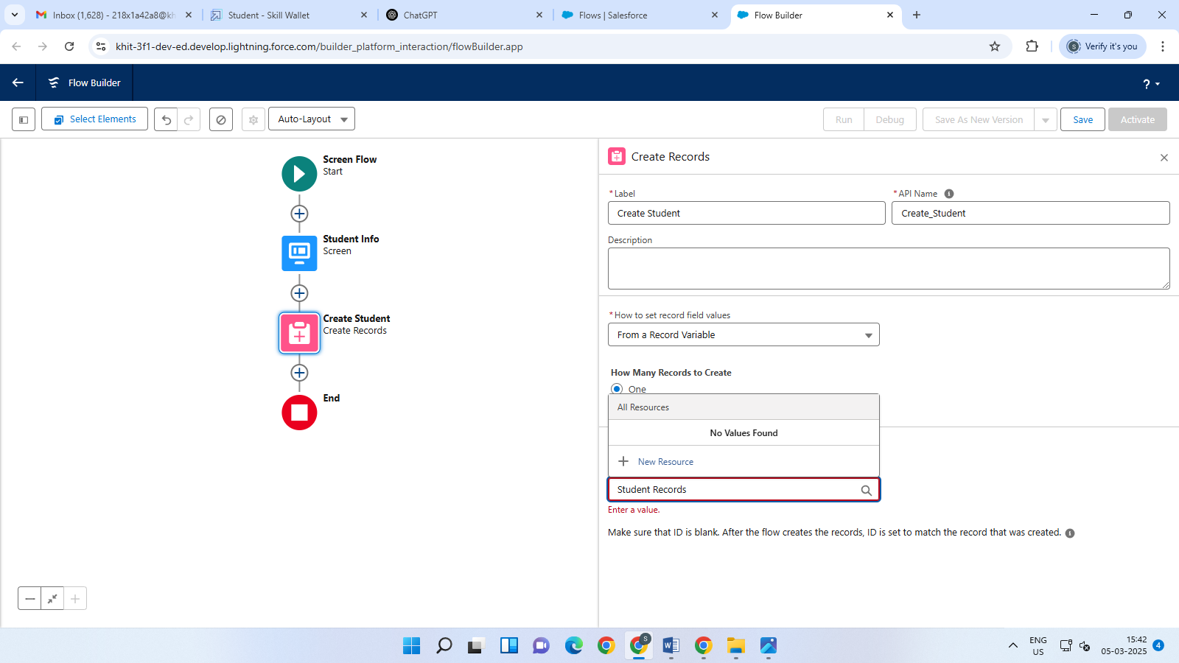

* Repeat the same add elements with Decision ,Get Record elements with in the student record element.
* **Create Registration Record using Create Records Element:**
* Add a Create element after the Get IELTS Rec element and label it as “Create IELTS Registration Rec”.
* Select “one” under How many records to Create, and select “Use separate resources, and literal values” under How to Set the record fields.
* Select Object: Registration
* Field: Course_Name__c  
  Value: {!Get_IELTS_Rec.Id}



### Create Email Text Template Variables for email body and subject:

* Click on the toggle toolbox in the top left corner, then click on “New Resource.”  
  Next, select **“Text Template”** as the **Resource Type**.
* Give the API name as **“StuRegistrationEmailTextTempBody”**, select **“view as plain text”**, and paste the following text in the body:

**"Dear {!StudentRecordRes.Name},**

Congratulations and welcome to EduConsultantPro!  
We’re excited to have you on board and look forward to supporting you throughout your educational journey.

Bestregards,  
 The EduConsultantPro Team"

* Click on done
* Repeat steps 1 & 2 to create an email text template for the email subject, label it as “StuRegistrationEmailTextTempSub”, write a text message in the body and save it.

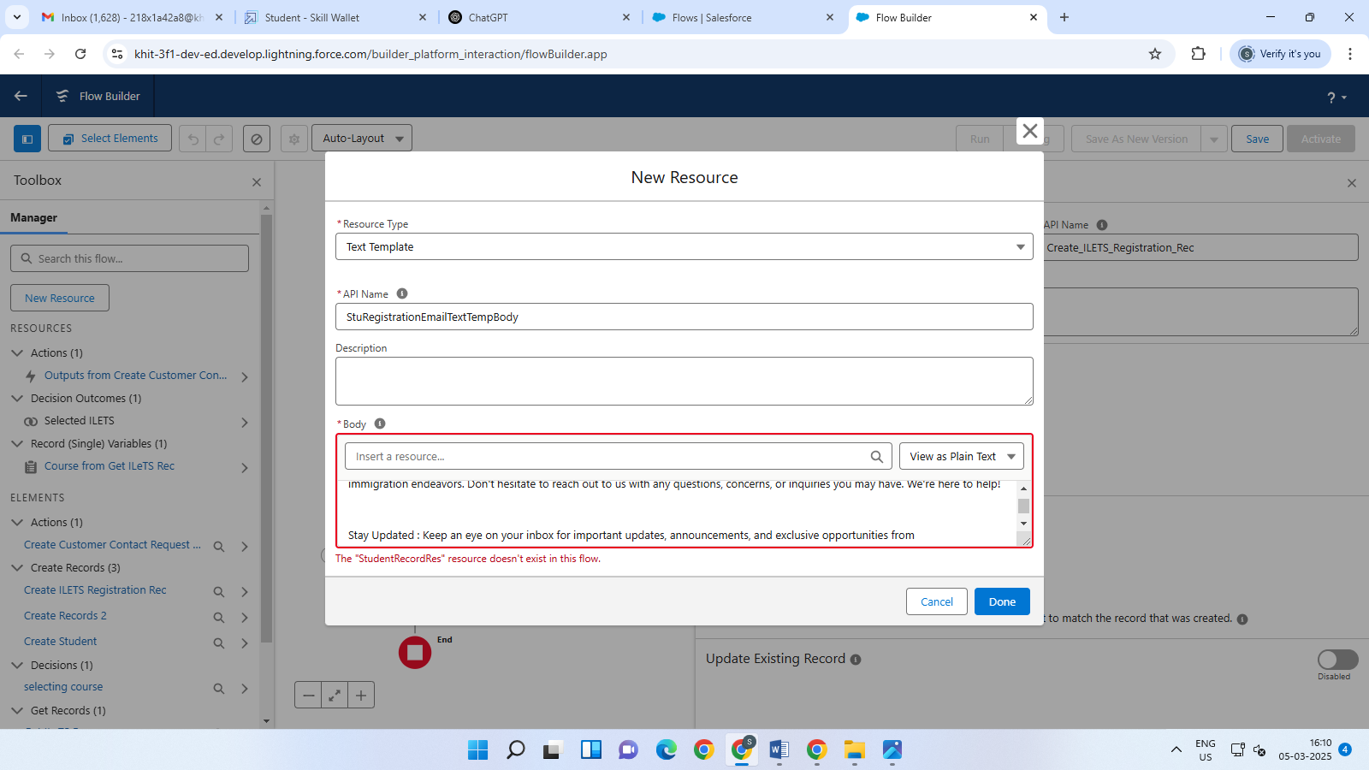

### Add an Action Element:

**1.** Add an **Action Element** after all the Decision paths and label it as **“Send Email to Student”**.

**2.** Under **“Set input values for selected action”**, include the following fields:

* **Body**: Use **{!StuRegistrationEmailTextTempBody}**  
  This references the text template you’ve created for the email body.
* **Recipient Address List**: Use **{!StudentRecordRes.Email__c}**  
  This dynamically pulls the student's email address from the record.
* **Subject**: Use **{!StuRegistrationEmailTextTempSub}**  
  This ensures the subject line is dynamically generated using the variable you've set for the subject

### Add Screen Element:

1. Add a **Screen Element** after the **Send Email to Student** Action Element and label it as **Success Screen**.
2. From the left-side panel, search for the **Display Text** component and drag it to the main panel. Label it as **SuccessMessage**.
3. In the **Resource Picker** box, paste the following text:

"Dear {!StudentRecordRes.Name},

Congratulations and welcome to EduConsultantPro!

We are delighted to inform you that your registration on our platform has been successfully completed. You are now part of our esteemed community dedicated to empowering students like you to achieve their educational and immigration aspirations.

Your registration details have been sent via email. Kindly check your inbox.

Thank you."

1. Click **Done**.
2. Save the flow and name it **“EduConsultPro Student Flow”**.

Your flow will now look as shown below.

### 

### Create Users

Created a user with a Standard platform user profile.

### User:

* Go to **Setup** → **Administration** → **Users** → **New User**.
* In the **Last Name** field, enter: **Consultant**.
* **Salesforce Platform** as the **License**.
* Choose **Standard Platform User** for the **Profile**.
* Fill in all the required fields (such as **First Name**, **Username**, **Email**, etc.).
* Click **Save**.

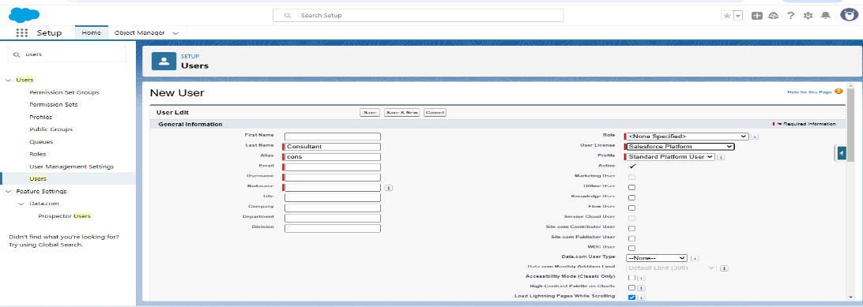

### Configure the User Settings:

* Go to **Setup** → **Administration** → **Users** → Click **Edit** next to your name.
* Scroll down to the bottom, and under **Approver Settings**, select **“Consultant”** in the **Manager** field.
* Click **Save**.

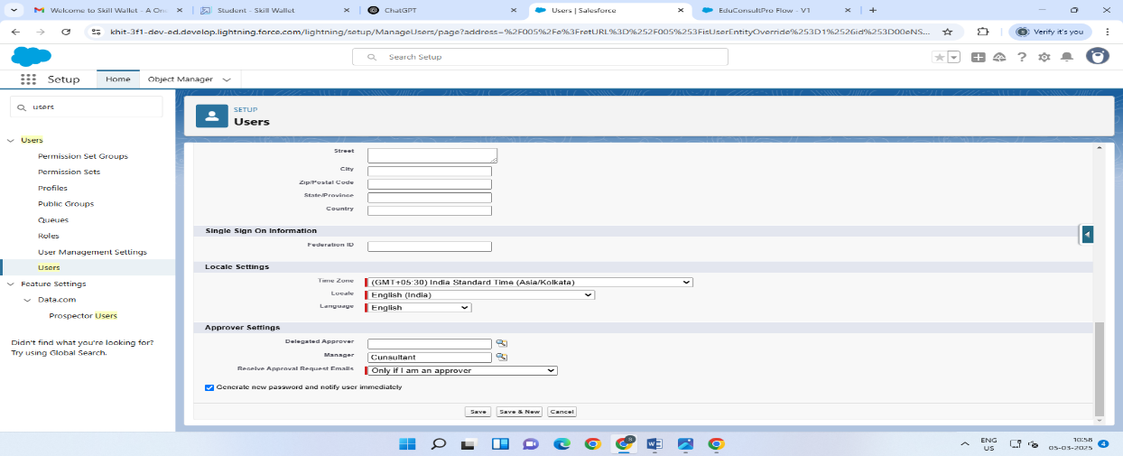

**Create an Approval Process for Consultant Object**

### Create an Email Template

1. From **Setup**, search for **Templates** in the **Quick Find** box and select **Lightning Email Templates**. Toggle it **on**.
2. Go to the **App Launcher**, search for **“Email Templates”**, and create a new folder with the desired name.
3. Create a new **Email Template**, select the folder created in the previous step, and enter the following text in the **HTML Value** section:

**"Dear {{{Appointment__c.Student_Name__c}}},**

I hope this email finds you well. I am writing to confirm the details of our upcoming appointment scheduled for {{{Appointment__c.Appointment_DateTime__c}}} regarding {{{Appointment__c.PurposeTopic__c}}}.

**Appointment Details:**

* + **Appointment No:** {{{Appointment__c.Name}}}
  + **Student Name:** {{{Appointment__c.Student_Name__c}}}
  + **Consultant Name:** {{{Appointment__c.Consultant__c}}}
  + **Date & Time:** {{{Appointment__c.Appointment_DateTime__c}}}
  + **Purpose:** {{{Appointment__c.PurposeTopic__c}}}

I look forward to our meeting and am prepared to address any questions or concerns regarding {{{Appointment__c.PurposeTopic__c}}}. Your satisfaction is my top priority.

If you have any topics or questions to discuss during our appointment, feel free to share them in advance.

If you need to reschedule or cancel, please notify me at your earliest convenience.

Thank you for choosing to work with me. I’m confident our collaboration will lead to positive outcomes.

If you have any questions before the appointment, don’t hesitate to reach out.

Looking forward to our meeting.

**Best regards,**

* + {{{Recipient.Name}}},
  + EduConsultantPro

1. Save the template as **"Submission Template"**.
2. Create two additional templates for **Approval** and **Rejection of Request** with similar content and format.
3. Modify the content of the **Approval** and **Rejection** templates to reflect approval or rejection messages as appropriate.
4. Save the **Approval** and **Rejection** templates with the respective names.

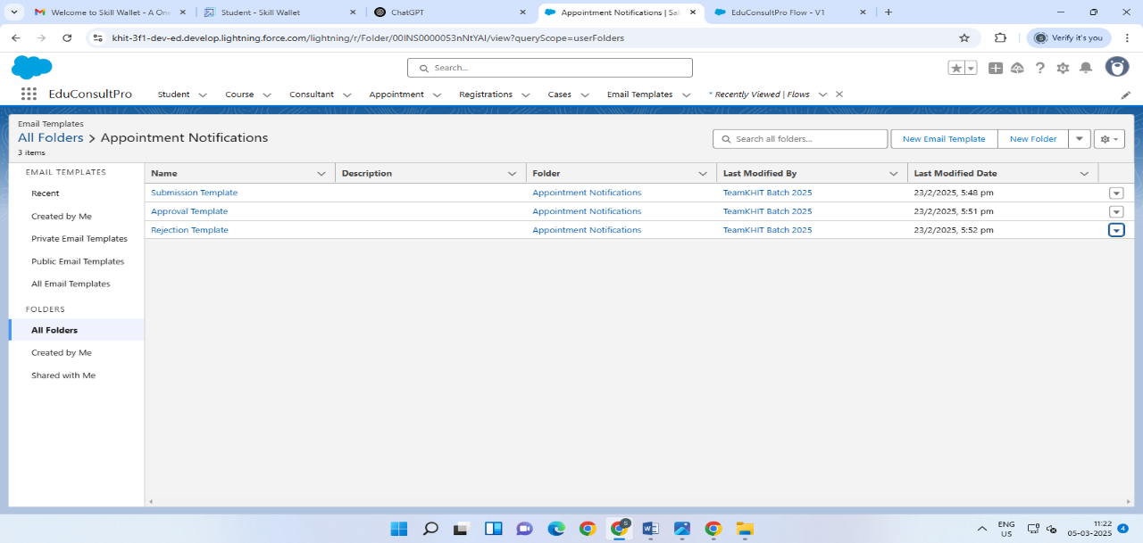

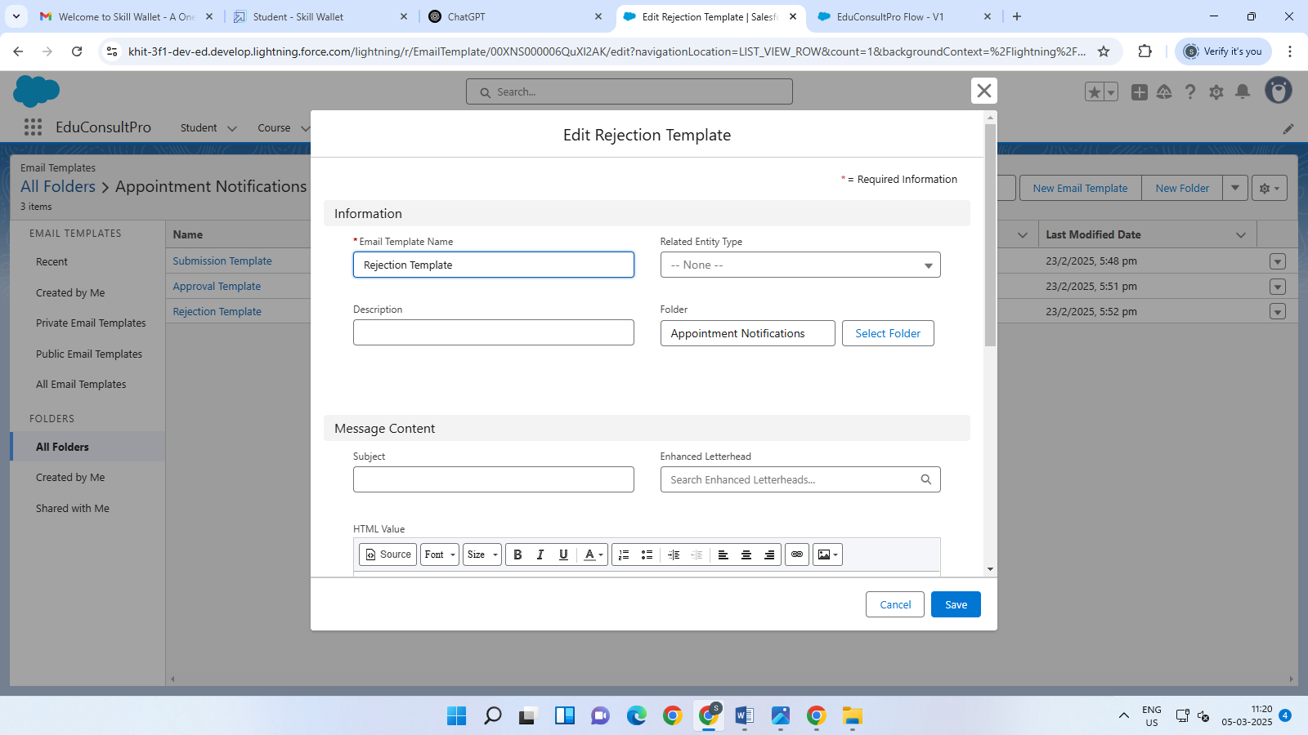

### Create an Approval Process:

1. From **Setup**, enter **Approval** in the **Quick Find** box, and then select **Approval Processes**.
2. Under **Manage Approval Processes For**, select **Appointment**.
3. Click **Create New Approval Process** and choose **Use Jump Start Wizard**.
4. Configure the approval process:
   * **Process Name**: Appointment Approval
   * Under **Select Approver**, choose **Manager** for the option: **“Automatically assign an approver using a standard or custom hierarchy field.”**
5. Click **Next**, then for **Automated Approver Determined By**, select **Manager**.
6. Under **Record Editability Properties**, select **Administrators OR the currently assigned approver can edit records during the approval process**.
7. Save the approval process.
8. Click **View Approval Process Detail Page**.
9. Under **Initial Submission Actions**, click **Add New** and choose **Field Update**. Configure it with these values:
   * **Field Name**: Submitted
   * **Field to Update**: Appointment: Status
   * **Value**: Pending
10. Click **Add New**, then select **Email Alert** and configure it with these values:
    * **Description**: Submission Email Alert
    * **Email Template**: Submission Template
    * **Recipient Type**: Select your name
11. Repeat steps 9-10 for **Final Approval** and **Final Rejection** actions.

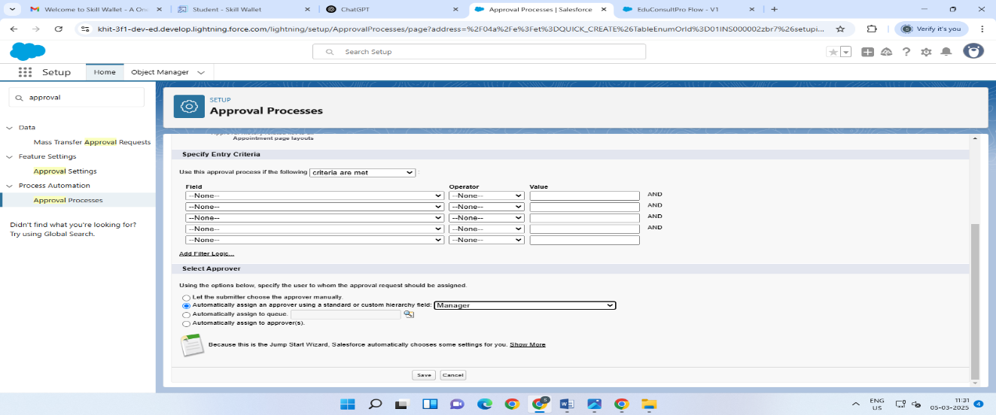

### Create a Record Triggered Flow

### Configure the Start Element:

* From **Setup**, enter **Flows** in the **Quick Find** box, then select **Flows**.
* Click **New Flow**.
* Select **Record-Triggered Flow**.
* Click **Create**. The **Configure Start** window will open.
* For **Object**, select **Appointment**.
* For **Trigger the Flow When**, select **A record is created**.
* The flow will now be configured as described.

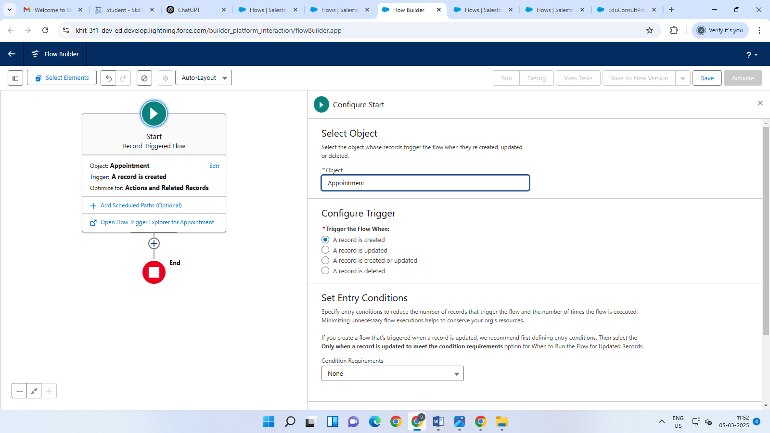

### Add an Action Element:

* Add an **Action** element after the **Start** element, select **Submit for approval** action, and label it as **"Approval SubFlow"**.
* Set the **RecordId** to **{!$Record.Id}**.
* Save the flow, label it as **"EduConsultPro Approval Flow"**, and click **Activate**.

### Create a ScreenFlow for Existing Student to Book an Appointment

### Add Screen Element:

1. From **Setup**, enter **Flow Builder** in the **Quick Find** box, then select **New Flow** and choose **Screen Flow**.
2. Add a **Screen** element.
3. In the **Screen Properties** pane, set the **Label** to **"Get Student Info"**.
4. Add two **Text** components from the left-side panel. Set the labels as follows:
   * **1st Text Component**: Label = **Enter Student Name**
   * **2nd Text Component**: Label = **Enter Student Email**

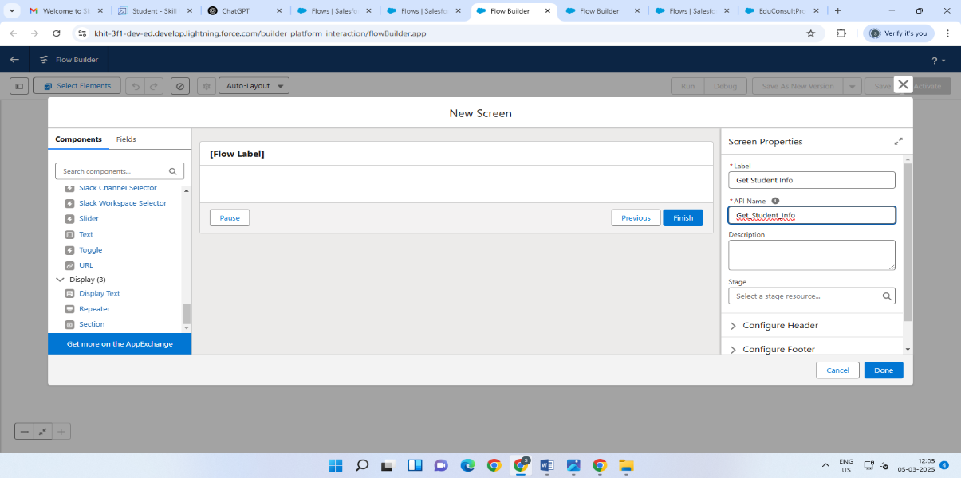

* Add the GetRecord and decision elements like as above
* **Create Appointment Record using Creaat Records Element:**
* Add a **Create Records** element after the **Get Consultant Rec** element and label it as **“Create Appointment”**.
* Under **How many records to Create**, select **One**.
* Under **How to Set the Record Fields**, select **Use separate resources, and literal values**.
* Select the **Object** as **Appointment**.
* Set the following field values:
* **Field**: **Appointment_DateTime__c**  
  **Value**: {!AppointmentRecordRes.Appointment_DateTime__c}
* **Field**: **Consultant__c**  
  **Value**: {!Get_Consultant_Rec.Id}
* **Field**: **Notes__c**  
  **Value**: {!AppointmentRecordRes.Notes__c}
* **Field**: **PurposeTopic__c**  
  **Value**: {!AppointmentRecordRes.PurposeTopic__c}
* **Field**: **Student_Name__c**  
  **Value**: {!Get_Rec.Id}

### Add Screen Element:

* Add a **Create Records** element after the **Get Consultant Rec** element and label it as **“Create Appointment”**.
* Under **How many records to Create**, select **One**.
* Under **How to Set the Record Fields**, select **Use separate resources, and literal values**.
* For **Object**, select **Appointment**.
* Configure the following field values:
  + **Appointment_DateTime__c**: {!AppointmentRecordRes.Appointment_DateTime__c}
  + **Consultant__c**: {!Get_Consultant_Rec.Id}
  + **Notes__c**: {!AppointmentRecordRes.Notes__c}
  + **PurposeTopic__c**: {!AppointmentRecordRes.PurposeTopic__c}
  + **Student_Name__c**: {!Get_Rec.Id

### Add an SubFlow Element:

* Add a **Subflow** element after the **Decision Element**, on the **Case** path.
* Search for and select **“Create a Case”**, then label it as **“Create Student Case”**.
* Save the flow and label it as **“EduConsultantPro Existing Student Flow”**.

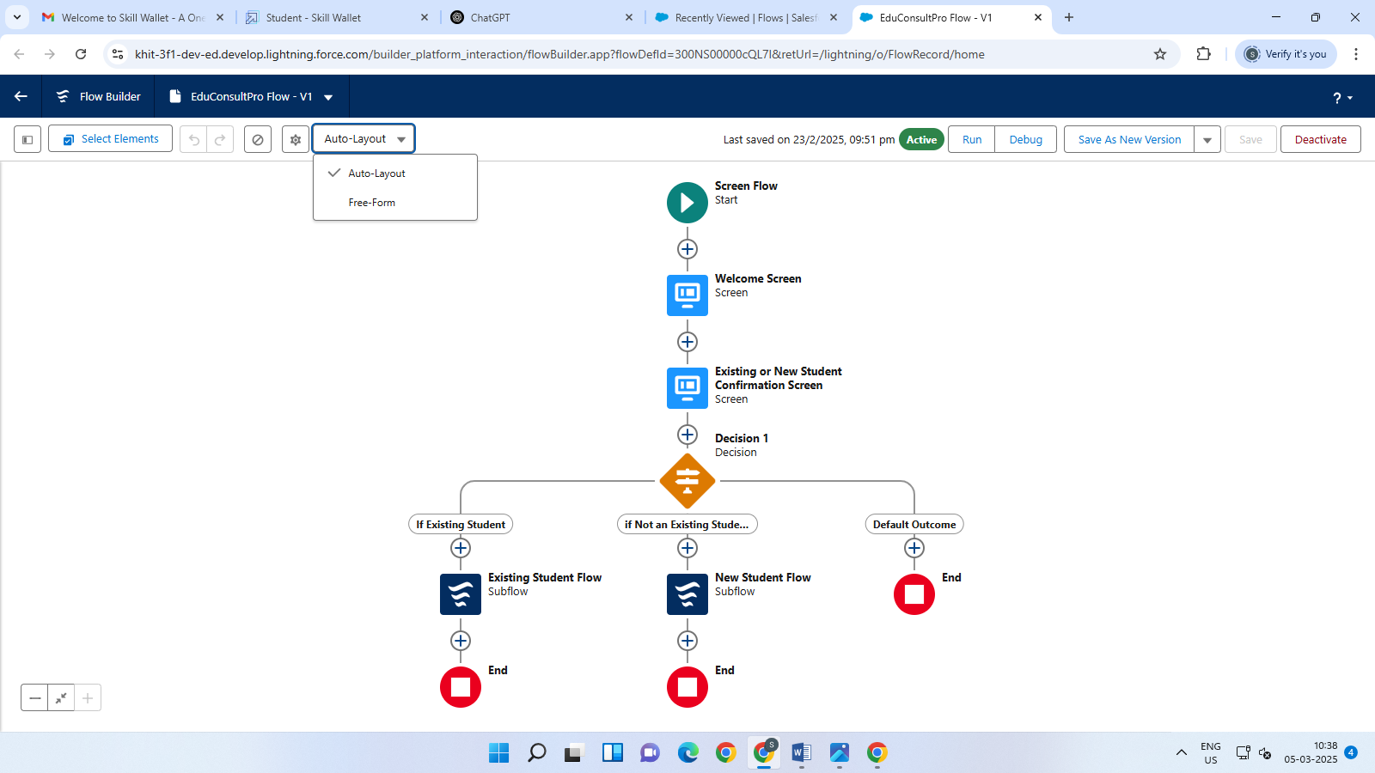

### Create a ScreenFlow to Combine all the flows at one place

### Add Screen Element:

* Add a **Screen** element and label it as **"Welcome Screen"**.
* From the left side panel, search for the **Display Text** component and drag it to the main panel. Label it as **"SuccessMessage"**.
* In the **Resource picker box**, paste the following text:
  + "Welcome to EduConsultantPro,  
    your premier destination for education and immigration solutions!
  + At EduConsultantPro, we understand that embarking on educational or immigration journeys can be both exhilarating and daunting. We're here to guide you every step of the way with expertise, dedication, and personalized support.
  + Whether you're seeking to pursue your academic dreams abroad, navigate the complexities of immigration processes, or enhance your professional skills through international opportunities, EduConsultantPro is your trusted partner.
  + Our team of seasoned consultants is committed to understanding your unique aspirations and crafting tailored strategies to help you achieve your goals efficiently and effectively. From selecting the right educational institution to navigating visa procedures, our comprehensive services cover all aspects of your journey.
  + At EduConsultantPro, we believe in fostering inclusive communities and unlocking the full potential of every individual. With our unwavering commitment to excellence and integrity, we strive to make your experience with us seamless and rewarding.
  + Welcome to EduConsultantPro – where your aspirations meet our expertise, and together, we pave the path to success. Let's embark on this transformative journey together!"
* Click **Done**.

### Add Screen Element

* Add a **Screen** element after the **Welcome Screen** element and label it as **“Existing or New Student Confirmation Screen”**.
* From the left side panel, add a **Radio Button** component. Label it as **“Are you an Existing Student?”**.
* Click **Add Choice** and type **“Yes”** in the input field, then click **Create Yes choice**.
* Repeat step 3 to create a **“No”** choice resource.
* Click **Done**.

And add the decision element also

* **Add an SubFlow Element:**
* Add a **Subflow** element after the **Decision 1** element on the **If Existing Student** path.
* Search for and select **“EduConsultantPro Existing Student Flow”**, then label it as **“Existing Student Flow”**.
* Save the flow and label it as **“EduConsultantPro Existing Student Flow”**.
* Click **Done**.

### Add an SubFlow Element:

* • Add a **Subflow** element after the **Decision 1** element on the **If Not an Existing Student** path.
* • Search for and select **“EduConsultantPro Student Flow”**, then label it as **“New Student Flow”**.
* • Save the flow and label it as **“EduConsultantPro Existing Student Flow”**.
* • Click **Done**.
* • Save the flow again and label it as **“EduConsultPro Flow”**.

### Create a lightning app page

### Create a lightning app page:

* From **Setup**, enter **App Builder** in the **Quick Find** box, then click **Lightning App Builder**.
* Click **New**, select **Home Page**, and then click **Next**.
* Step through the wizard:
  + Name the page **“EduConsultPro Home Page”**.
  + Select the **Standard Home Page** template, and then click **Done**.
* Drag the **Flow** component to the top-right region.
* Search for **“EduConsultPro Flow”** and click **Save**.
* Click **Activate**, then **App and Profile**. Click **Assign to Apps and Profiles**.
* Select the **Sales app**, then click **Next**.
* Scroll down and select the **System Administrator** profile, then click **Next**.
* Review the assignment and click **Save**.

### 

**Future Recommendations for the Student Admission Application Process:**

1. **Automate Data Validation:**
   * **Real-Time Data Checks**: Implement validations to check if the provided data (e.g., date of birth, email format) is correct in real-time to avoid submission errors.
   * **Document Validation**: Use an automated document verification system to confirm if the uploaded files are clear, complete, and meet requirements.
2. **Integration with External Systems:**
   * **External System Integration**: Integrate the flow with external platforms like university student information systems (SIS) or document management systems for seamless data transfer. This will ensure that the application data is automatically updated across systems.
   * **Online Payment**: For application fees, integrate a payment gateway to allow students to pay online as part of the application process.
3. **Dynamic and Personalized Form Sections:**
   * **Dynamic Form Fields**: Based on the student’s initial selections (e.g., program type, course, etc.), show

**Tesing And Validation**

* **Data Accuracy and Synchronization**: Ensure that student and service data (e.g., course enrollment, grades, support requests) is accurately captured and synchronized across Salesforce and other systems, with real-time updates.
* **User Role and Permissions**: Verify that users with different roles (students, faculty, admin) have appropriate access levels to view and manage data, ensuring that each user can only access the information relevant to their role.
* **Service Request Tracking**: Test the ability of the CRM to log, track, and assign service requests (e.g., technical support, course inquiries), ensuring that notifications and follow-ups are properly handled.

### Key scenarios Addressed by Salesforce During the

• **Customer Relationship Management (CRM):** Salesforce helps the institution manage interactions with customers (students, clients, or members), tracking communication, service requests, and follow-ups to ensure personalized service.

• **Service Request Tracking:** The system enables the tracking of service requests or issues raised by customers, ensuring they are assigned, monitored, and resolved promptly.

• **Automated Workflows:** Salesforce automates repetitive tasks like reminders for renewals, payment collections, or follow-ups, enhancing efficiency and ensuring consistency in service delivery.

• **Data Centralization:** The platform centralizes customer and service data, allowing different teams to access and update information in real-time for better collaboration and decision-making.

• **Reporting and Analytics:** Salesforce provides robust reporting and analytics tools to track performance metrics, customer satisfaction, and service delivery outcomes, helping the institution make data-driven decisions.

• **Customization of Service Offerings:** Institutions can tailor the services they offer (e.g., courses, memberships, etc.) by leveraging Salesforce’s customization capabilities to meet the specific needs of their customers.

### OUTCOME:

* **Centralized Student Data**: Salesforce CRM will centralize all student information, including enrollment, academic records, and service requests, for easy access and management.
* **Enhanced Communication**: The system will streamline communication between students, faculty, and support staff, improving response times and ensuring important updates are delivered on time.
* **Personalized Support**: Salesforce will allow the institution to track individual student needs and provide personalized support, enhancing the student experience.
* **Efficient Service Management**: The CRM will track and manage service requests such as admissions inquiries, course changes, and technical support, ensuring quicker resolutions.
* **Data-Driven Insights**: Salesforce analytics will provide insights into student engagement and service trends, enabling the institution to make informed decisions and improve services.
* **Automated Notifications**: Automated alerts and reminders will ensure students and staff stay updated on important deadlines, events, and course information.

### 

### Conclusion

In conclusion, implementing a CRM application for managing the services offered by an institution significantly enhances the efficiency of customer relationship management. It streamlines processes like service request tracking, follow-ups, and issue resolution, ensuring a seamless experience for both the institution and its customers. The centralization of data facilitates better collaboration and decision-making, while automation improves operational efficiency. With customizable features, the institution can tailor services to meet specific customer needs. Ultimately, the CRM application supports improved service delivery, increased customer satisfaction, and data-driven insights for continuous growth and improvement.